4.1 Double Integrals over Rectangular Regions Worksheet

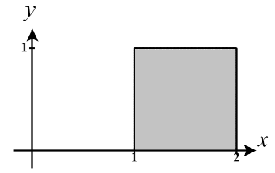
- Find the volume of the solid beneath the paraboloid and above the region .

A picture of the region R is shown at the right.
We know that the volume of the solid is given by

We calculate this double integral as follows:

- Calculate .
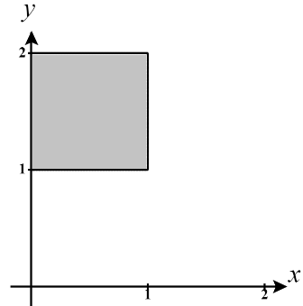
A picture of the region of integration is shown at the right.
We calculate this double integral as follows:
Let then . Our bounds become . Then,

- Determine the value of the volume communicated by the double integral for each of the following regions, using only simple geometry formulas.
- .

We are integrating over a rectangle here with dimensions of 1 and 8. We are finding the volume below the surface of and so our region is the shape of a rectangular prism with height 3. Therefore, .

- D is a circle of radius 4.

We are integrating over a circle and finding the volume below the surface of and so our region is the shape of a cylinder. Therefore, .

- D is determined by the curves, .

We are integrating over a triangle region with base 1 and height 1. This means that we are trying to find the volume of a triangular prism. Therefore, .

- Determine if each of the following statements are TRUE or FALSE.

- Suppose that is a continuous function over . There is no difference in the values of the integrals and .

TRUE! The region being integrated over here is rectangular and so the order of integration can always be changed.

- A double integral can be used to find volume under a surface and also the area of a region.

TRUE! Remember that represents the volume of the rectangular prism with base area of D and height of 1. Therefore . This means that the double integral can compute a volume but since it returns the area of region D as this volume, we can also think of this double integral as computing the area of D.

- The double integral represents triple the area of D.
TRUE! Note that and we know that represents can be thought to represent the area of D.

